Electromyography (sEMG, a special technique for studying muscle signals).

Various mathematical techniques and Artificial Intelligence (AI) been applied in evolvable hardware chip for the mapping of EMG inputs to desired hand actions. Mathematical models include wavelet transform, time-frequency approaches, Fourier transform, statistical measures, and higher-order statistics. AI approaches towards signal recognition include Artificial Neural Networks (ANN), and fuzzy logic system.

A nerve is a bundle of fibers composed of neurons that uses electrical and chemical signals to transmit sensory and motor information from one body part to another.

EMG signify electromyography. It is a muscle electrical signals investigation. The electromyogram is occasionally called myoelectric activity. Tissue of muscle carries electrical potentials as nerves do, and name given to these electrical signals indicates potency of muscle movement. The recording information method available in these muscular motion potentials is known as Surface Electromyogram.

When sensing and recording an electromyogram signal, there are two basic concerns that are concerned about effect and signal integrity. SNR and signal distortion. Signal to Noise Ratio (SNR) is energy ratio in electromyogram signals is the ratio of energy in noisy signal. Generally, noise is described as electrical signals that are not part of desired Electromyogram signal. Signal distortion is, relative contribution of any frequency component in Electromyogram signal should not be changed.

Two kinds of electrodes were utilized to obtain the signal of muscle: Invasive and non-invasive electrode. When the electromyogram is obtained directly from the skin-mounted electrodes, signal is a combination of all fibers of muscle action potentials that occur in muscles below deep. These action potentials occur at random intervals. For this reason, at any time, Electromyogram signal can either be a negative or a positive voltage. Individual muscle fiber action potentials are obtained utilizing wire or needle electrodes placed directly into muscle. Action Potential of Motor Unit in that a combination of fibers of muscle action potentials from all single motor unit fibers of muscle is detected by an electrode of skin surface (non-invasive) or a needle electromy (invasive) Basmajian and De Luca (1985). EMG signal simple model was illustrated at equation 1: (𝑛𝑛) = ∑ (𝑟𝑟)𝐸𝐸(𝑛𝑛 − 𝑟𝑟) + 𝑊𝑊(𝑛𝑛) 𝑛𝑛−1 𝑟𝑟=0.

The signal is picked up at the electrode and amplified. Typically, a differential amplifier is used as a first stage amplifier. Additional amplification stages may follow. Before being displayed or stored, the signal can be processed to eliminate low-frequency or high-frequency noise, or other possible artifacts. Frequently, the user is interested in the amplitude of the signal. Consequently, the signal is frequently rectified and averaged in some format to indicate EMG amplitude.

### Feature Extraction

For feature extraction, a raw EMG signal is represented as a feature vector and used as an input to the classifier. The feature extraction provides pattern information by having particular variables or parameters in signal processing. The success of a pattern classification system relies upon the choice of features used to represent the raw EMG signals [14]. A time-frequency analysis had received substantial attention rather than independent time and frequency analysis of highly fluctuated waveforms. The examples of time-frequency approaches are [15]:

* Choi Williams Distribution (CWD).
* Wavelet Transforms (WT).
* Short-Time Fourier Transform (STFT).
* Wavelet Packet Transform (WPT).

WT is an efficient mathematical tool to analyze a highly fluctuated signal like EMG [16]. WT had good resolution and high performance for visualization of neuropathy (e.g., muscular disease) and myopathy (e.g., nerve damage) activities compared to STFT [17]. WT consists of continuous and discrete forms. Discrete wavelet transforms (DWT) is a special form of WT whereas it provide an effective processing of the signal in time and frequency domains [10]. DWT had been used as feature extraction in real-time signals of hand motion commands [11] and differentiating types of muscle movements [8]. On the other hand, Khusaba and Al-Jumaily proposed a novel approach of feature extraction which combined the Wavelet Packet Transforms (WPT) that extracts the features of the EMG signal from multiple channels with the Fuzzy C-Means (FCM) in order to determine those wavelet features that are maximized the classification [16].

FCM is one of clustering techniques, which had been used very successfully in many applications especially in pattern classification. A Fuzzy logic approach has been proven to be used in data analysis, decision making and other fields in the biomedical sciences [16]. Explicitly, an FCM algorithm yields excellent classification accuracy in pattern recognition as mentioned by Kocyigit and Korurek [18]. The FCM algorithm attempts to cluster the pattern by minimizing an objective function dependent of cluster locations

An unfiltered (exception: amplifier bandpass) and unprocessed signal detecting the superposed Motor Unit Action Potentials (MUAPs) are called a raw EMG signal. The raw EMG transmitted waveforms is displayed on the screen. Then, the raw data EMG will be recorded and saved in a comma-separated values (CSV) format.

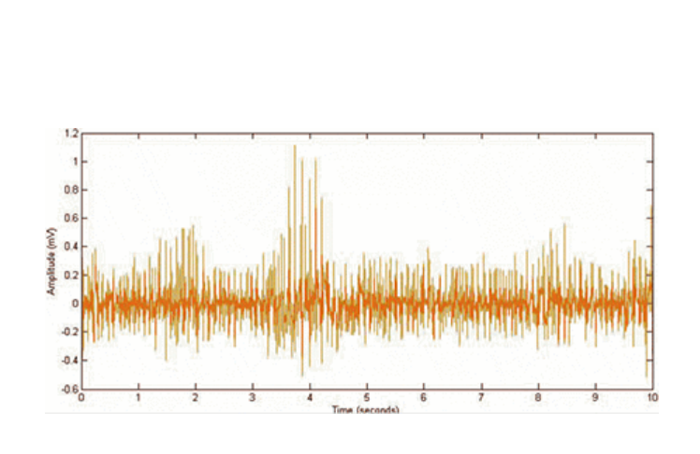

#### Pre-Processing

The collected data commonly contain noises. Corrupted EMG signals are the major problem in the analysis. A signal enhancement (pre-processing) consists two steps: filtering and rectification is applied to extract unintended features (e.g., ECG noise contained in the EMG signal, unintended features and etc.). In this paper, fifth-order Butterworth high-pass filtering with cutoff frequencies of 40 Hz is applied for substantial cancellation of ECG artifact in EMG signal using MATLAB software (see Fig. 6).

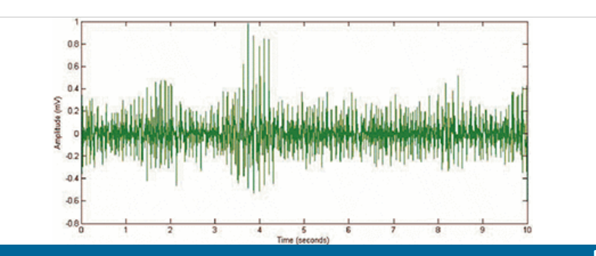

Fifth-order butterworth high-pass filtering on the ECG artifact removal with cutoff frequencies of 40 hz

[Show All](https://ieeexplore.ieee.org/document/7235878/all-figures)

Then, the filtered of EMG signal is rectified using full-wave rectification

### ****EMG signal decomposition****

EMG signals are the superposition of activities of multiple motor units. It is necessary to decompose the EMG signal to reveal the mechanisms pertaining to muscle and nerve control. Various techniques have been devised with regards to EMG decomposition.

Decomposition of EMG signal has been done by wavelet spectrum matching and principle component analysis of wavelet coefficients. According to Jianjung et al. ([12](https://www.ncbi.nlm.nih.gov/pmc/articles/PMC1455479/#B12)), more than one single motor unit (SMU) potential will be registered at same time overlapping with each other, especially during a strong muscle contraction. In 1997, they developed a technique using wavelet transform to classify SMU potentials and to decompose EMG signals into their constituent SMU potentials. The distinction of this technique is that it measures waveform similarity of SMU potentials from wavelet domain, which is very advantageous. This technique was based on spectrum matching in wavelet domain.

 However, extensive processing is required to distinguish individual MUAPs from EMG signals. This process, known as “decomposition”, generally involves the following steps- (a) EMG data acquisition – usually by means of multiple electrodes; (b) pre-processing – to improve the signal-to-noise ratio and highlight MUAPs; (c) windowing – selection of the regions of EMG activity; (d) feature extraction – the EMG data are processed and transformed into numerical features, generally a multidimensional array; and (e) pattern recognition – detected MUAPs with similar features are separated into groups, representing the action potentials of specific motor units (MUs). The last step assumes that MUAPs from the same MU would share a distinct signature that accounts for similarities in the extracted features.

**EMG signal processing**

Raw EMG offers us valuable information in a particularly useless form. This information is useful only if it can be quantified. Various signal-processing methods are applied on raw EMG to achieve the accurate and actual EMG signal.

Wavelet Analysis

The time-frequency plane is one of the most fundamental concepts in signal analysis. The Wigner-ville distribution (WVD) is one time-frequency representation method, which is used for analyzing the EMG signal. In 1992, Ricamato et al. showed that it is possible to present the frequency ranges of the motor unit by WVD [[34](https://www.ncbi.nlm.nih.gov/pmc/articles/PMC3821366/#b34-sensors-13-12431)]. WVD is highly concentrated in the instantaneous frequency and time of the signal, which is an excellent localization property of this method.

#### **Time-frequency approach**

Variations in muscle force cause a modification of the frequency content of the signal.

Attempts to gain quantitative information from EMG recordings have been extensively investigated when signal is represented as function of time (time domain). Cohen class transformation, Wigner-Ville distribution (WVD), and Choi-Williams distribution are some of the time-frequency approaches used for EMG signal processing. A sustained muscle contraction the spectral components of the surface myoelectric signal are compressed towards the lower frequencies.

#### **Autoregressive model**

The autoregressive (AR) time series model has been used to study EMG signal. A surface electrode will pick up EMG activity from all the active muscles in its vicinity, while the intramuscular EMG is highly sensitive, with only minimal crosstalk from adjacent muscles. Thus, to combine convenience and accuracy there is a great need to develop a technique for estimating intramuscular EMG and their spectral properties from surface measurement. Researchers have represented sEMG signal as an AR model with the delayed intramuscular EMG as the input.

#### **Artificial intelligence**

Some Artificial Intelligence techniques mainly based on Neural Networks have been proposed for processing EMG signal. This kind of technique is very useful for real-time application like EMG signal recording and analysis.

A real-time application of artificial neural network that can accurately recognize the myoelectric signal (MES) is proposed by Del and Park ([38](https://www.ncbi.nlm.nih.gov/pmc/articles/PMC1455479/#B38)) in 1994. According to their research, MES features are first extracted through Fourier analysis and clustered using fuzzy c-means algorithm. Fuzzy c-means (FCM) is a method of clustering which allows data to belong to two or more clusters. The neural network output represents a degree of desired muscle stimulation over a synergic, but enervated muscle. Real time operation is achieved by taking advantage of hardware multipliers present in Digital signal processing (DSP) processors to perform Fast Fourier Transform for feature extraction and neurode input integration for featured classification.

Electrical noise, which will affect EMG signals, can be categorized into the following types:

1. Inherent noise in electronics equipment: All electronics equipment generate noise. This noise cannot be eliminated; using high quality electronic component can only reduce it.

2. Ambient noise: Electromagnetic radiation is the source of this kind of noise. The surfaces of our bodies are constantly inundated with electric-magnetic radiation and it is virtually impossible to avoid exposure to it on the surface of earth. The ambient noise may have amplitude that is one to three orders of magnitude greater than the EMG signal.

3. Motion artifact: When motion artifact is introduced to the system, the information is skewed. Motion artifact causes irregularities in the data. There are two main sources for motion artifact: 1) electrode interface and 2) electrode cable. Motion artifact can be reduced by proper design of the electronics circuitry and set-up.

4. Inherent instability of signal: The amplitude of EMG is random in nature. EMG signal is affected by the firing rate of the motor units, which, in most conditions, fire in the frequency region of 0 to 20 Hz.

Electrical noise, which will affect EMG signals, can be categorized into the following types:

1. Inherent noise in electronics equipment: All electronics equipment generate noise.

2. Ambient noise: Electromagnetic radiation is the source of this kind of noise. The surfaces of our bodies are constantly inundated with electric-magnetic radiation and it is virtually impossible to avoid exposure to it on the surface of earth

3. Motion artifact: There are two main sources for motion artifact: 1) electrode interface and 2) electrode cable. Motion artifact can be reduced by proper design of the electronics circuitry and set-up.

4. Inherent instability of signal: The amplitude of EMG is random in nature. EMG signal is affected by the firing rate of the motor units.